Project Smart Link Add-in

User Guide

Version 1.0

Contents

Overview 1

Excel add-in 1

Word add-in 1

## Overview

## Formal proposals use to include a considerable amount of information that the team has worked on in spreadsheets. This is usually financial information calculated through formulas and calculations in Microsoft Excel. When working on getting the opportunity right, these data can change many times, forcing you to copy the new values from the Excel spreadsheet and paste them in the formal proposal Word document to replace the old values.

## The more complex your document gets, and the more information it contains, the more time it will take to update this document with all the latest values, not to mention the higher risk of mistakenly putting an incorrect value in the document.

## Project Smart Link was designed to tackle this very problem, by introducing the concept of "Source Points" and "Destination Points". A source point is the place in which the information is born, that is, the cell containing the specific calculation in Excel. You can think of this point as a TV station; it is the place that broadcasts the values to the rest of the town. When this information is published from the source points, the formal proposal Word document, containing destination points (one for each source point) will have its values updated with a simple click. You can think of a destination points as a TV that displays what the TV station sent to it. This means that now everyone can work on their spreadsheets without worrying about having to update the formal proposal document, and whenever you want to see an updated version of the document, all you need to do is click on Project Smart Link's refresh button, and you're done updating the document.

## Excel add-in

The Excel add-in is used for creating the source points, tables and charts that will be linked to a Word document.

To start creating source points, tables and charts, first you need to click the “Add” button:

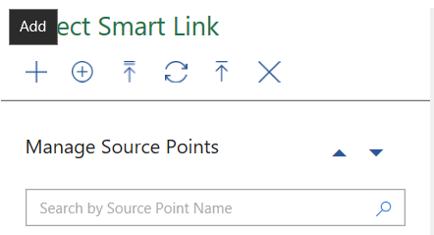

From there, you’ll be able to select what kind of source you want to create:



We’ll go through each of these, starting with Points.

### Points

Choose the source point name and value. To do this, first select the cell you want to be the name of the point:



Once selected, in Project Smart Link click on the grid icon in the Source Point Name field. The field will then be filled automatically with the coordinates of the point you chose:

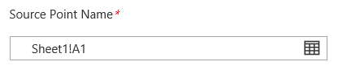

Repeat the same process for the value:

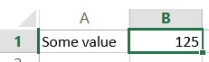

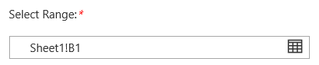

Click “Save”. You just created a source point. Now let’s move to charts.

### Charts

Following the same steps as before, select “Add” and then “Chart”:



In this case, simply write a title for the chart and select from the list the chart that you want to be the source from the list.

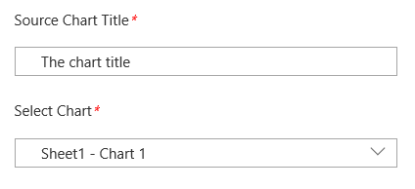

Click “Save” and you’re done.

### Tables



First, write a short title for the source table:

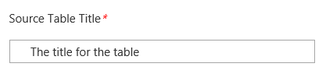

Then, select in the spreadsheet the range that you want to act as the source table.

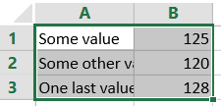

Now, click the little grid icon in the “Source Table Range” field to select the table. The coordinates of the table range should appear in the field:

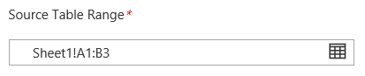

## Word add-in

In word, you can add destination points, charts and tables. Let’s take a look, using the sources we created in the previous sections. First, just like in the Excel add-in, click the big plus button to add a new destination.

You should then be displayed something like this:

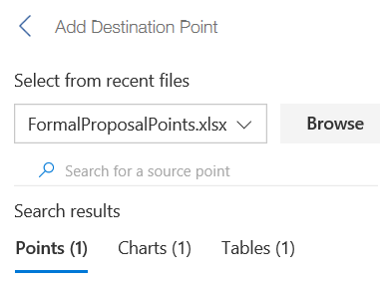

Notice that, just like before when we were working with sources, you have three tabs: one for points, the next one for charts, and the last one for tables. Depending on what tab you open there, you will see a list of all sources available of that specific type of source for the selected document. If you want to look at sources from a different document, click “Browse” next to the dropdown box and select a document in the dialog box that appears.

### Points

To add a point, click on its name on the list and you should see this:

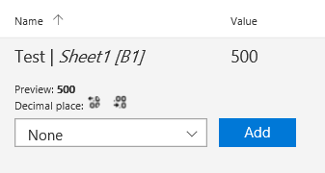

In the dropdown, you can customize how the value will be displayed in the document. Once you’re ready setting the format, click “Add” and the destination point will be added to the document.

### Charts

To add a destination chart, simply click on its name in the list and then choose “Add”:

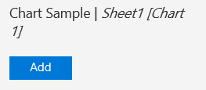

Remember, destinations are always added at the cursor’s current position, so don’t forget to put the cursor in the place you want the chart to appear before clicking “Add”.

### Tables

To add a table, you have two options: you can either add it as an image or add it as a table. Click on the one you prefer:

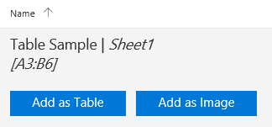

This adds the table (or image) where the cursor is at.

## Refreshing

In the Word add-in, when you see this message:

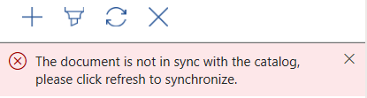

You need to click the refresh button (the third one above the message, from left to right). This will bring in the latest changes from all the source points into the document.

## Publishing changes in Excel

When the values change in Excel, you need to publish those changes to make them available to documents and presentations using them.

To do that, click on the “Refresh All” button, and you should see the following:

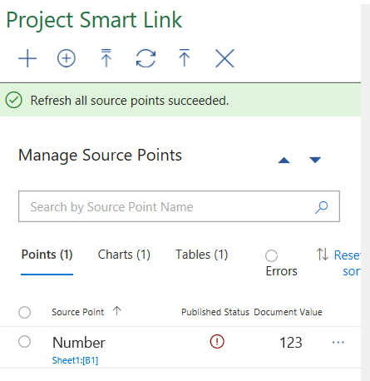

Finally, to publish all the changes, click on the “Publish All” button.